Project - High Level Design
on
  - Deploy Insurance App to Kubernetes
  - Course Name: Devops

Institution Name: Medicaps University – Datagami Skill Based Course

Student Name(s) & Enrolment Number(s):
Sr no | Student Name | Enrolment Number
1 | ISHITA GARG | EN22CS301446
2 | ISHITA JAIN | EN22CS301447
3 | JANVI MAHAJAN | EN22CS301455
4 | JANAK DALKE | EN22CS301452

Group Name: Group 04D4
Project Number: DO-40
Industry Mentor Name: Mr. Vaibhav
University Mentor Name: Prof. Avnesh Joshi
Academic Year: 2026

Table of Contents
- Introduction.
  - Scope of the document.
  - Intended Audience
  - System overview.
- System Design.
  - Application Design
  - Process Flow.
  - Information Flow.
  - Components Design
  - Key Design Considerations
  - API Catalogue.
- Data Design.
  - Data Model
  - Data Access Mechanism
  - Data Retention Policies
  - Data Migration
- Interfaces
- State and Session Management
- Caching
- Non-Functional Requirements
  - Security Aspects
  - Performance Aspects
- References

1. Introduction
The Multimodal Insurance Creator is a Generative AI-based application designed to simplify insurance-related information by converting complex policy concepts into easy-to-understand text and visual explanations. The system helps users better understand insurance policies, coverage, and benefits through a combination of natural language processing and image generation.
In its initial form, the system operates as a standalone application where the backend interacts with external AI services to generate outputs. However, standalone deployment introduces several challenges such as limited scalability, difficulty in maintaining consistency across environments, and lack of automated deployment mechanisms.
To overcome these limitations, this project introduces a DevOps-based deployment model using containerization and orchestration technologies. The application is packaged using Docker containers and deployed on a Kubernetes cluster using Minikube. This approach ensures that the system can handle multiple user requests efficiently, maintain high availability, and support continuous updates without interrupting service.
The system also integrates a Continuous Integration and Continuous Deployment (CI/CD) pipeline, which automates the process of building, testing, and deploying the application. This reduces manual effort, improves reliability, and ensures faster delivery of updates.
The purpose of this document is to provide a detailed high-level design of the system, including its architecture, component interaction, deployment strategy, and operational considerations.

1.1. Scope of the document
This document defines the design of the Multimodal Insurance Creator when deployed using DevOps practices on a Kubernetes environment.
The scope of this document includes:
- Description of the overall system architecture and deployment model
- Detailed explanation of application layers and components
- Step-by-step process and information flow within the system

- Design of Kubernetes resources such as pods, services, and deployments
- Description of CI/CD pipeline and automation process
- Data handling, storage, and access mechanisms
- Interface definitions and communication methods
- State management and caching strategies
- Security and performance considerations
This document focuses on high-level design and does not include low-level implementation details such as code structure or configuration files.

1.2. Intended Audience
This document is intended for the following audience:
- Project mentors and evaluators who need to understand the system design
- Developers and DevOps engineers working on deployment and maintenance
- Students learning containerization, Kubernetes, and AI system deployment
- Technical reviewers interested in system architecture and workflow
The document uses structured and descriptive language so that it is accessible to both technical and non-technical readers.

1.3. System overview
The Multimodal Insurance Creator is a web-based application that uses AI to generate explanations for insurance-related queries. The system combines text and image generation to provide a multimodal output that enhances user understanding.
In the DevOps-enabled version of the system, the application is deployed in a containerized environment managed by Kubernetes. This ensures that the system is scalable, reliable, and easy to maintain.
The system consists of the following major parts:
- User Interface for receiving user queries
- Backend application for processing requests

- AI service integrations for generating text and images
- Docker container for packaging the application
- Kubernetes cluster for managing deployment and scaling
- CI/CD pipeline for automating build and deployment
The overall working of the system can be divided into two flows:
Application Flow:
The user submits a query, which is processed by the backend, and the result is generated using AI services and displayed to the user.
Deployment Flow:
The developer pushes code changes to a repository, which triggers a CI/CD pipeline. The pipeline builds a Docker image, pushes it to a container registry, and deploys it to the Kubernetes cluster using a rolling update strategy.
This combination of application logic and deployment automation ensures efficient system operation and continuous availability.

2. System Design
The system design describes how different parts of the system are structured and how they interact with each other. The design follows a modular and layered approach, where each component has a clearly defined role.
This approach helps in improving system maintainability, scalability, and flexibility. It also allows new features or services to be added in the future without affecting the overall structure.
2.1. Application Design
The application is designed using a layered architecture, where each layer performs a specific function.
User Layer
The user layer represents the interaction between the user and the system. It provides a simple interface where users can enter their queries and view the generated responses. The goal of this layer is to ensure ease of use and accessibility.
Interface Layer
The interface layer acts as a bridge between the user interface and the backend system. It receives user input and forwards it to the backend for processing. It also returns the final response back to the user.
Application Layer
The application layer contains the core business logic of the system. It processes user queries, prepares prompts for AI models, and manages communication with external services. It also combines the outputs received from different services into a unified response.
Container Layer
The container layer packages the application along with all its dependencies into a Docker image. This ensures that the application runs consistently across different environments without compatibility issues.
Orchestration Layer
The orchestration layer is managed by Kubernetes. It is responsible for deploying, scaling, and managing containerized applications. It ensures that the required number of application instances are always running and replaces failed instances automatically.

External Services Layer
This layer includes third-party AI services used for generating text and images. These services are accessed through APIs and provide the core functionality of the system.
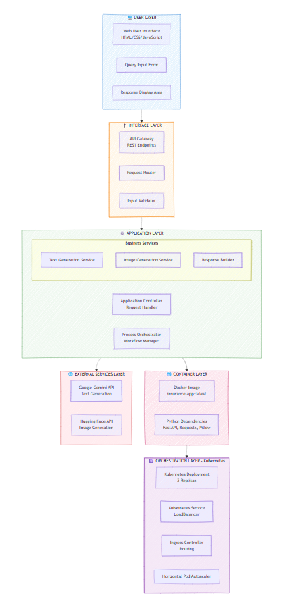

2.2. Process Flow
The process flow describes the step-by-step execution of the system when a user interacts with it.
- The user enters an insurance-related query through the user interface.
- The interface layer receives the query and forwards it to the backend application.
- The backend validates the input and prepares the necessary prompts for AI processing.
- The backend sends a request to the text generation API to generate a simplified explanation.
- At the same time, the backend sends another request to the image generation API to create a relevant visual representation.
- Both APIs process the request and return their respective outputs.
- The backend receives the outputs and combines them into a structured response.
- The final response is sent back to the user interface.
- The user interface displays the text explanation along with the generated image.
This process ensures that the user receives a complete and easy-to-understand explanation.
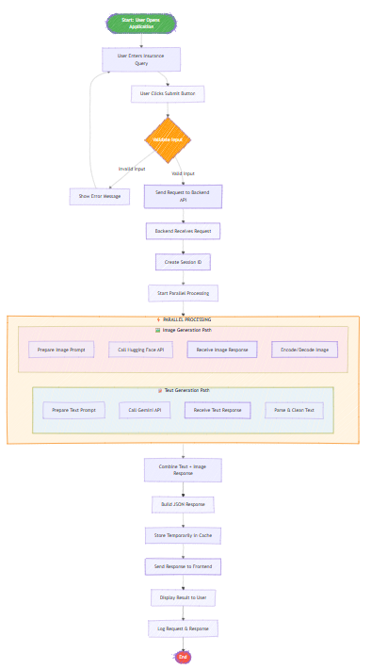

2.3. Information Flow
The information flow describes how data moves between different components of the system.
The flow is as follows:

User → Interface Layer → Backend Application → AI Services → Backend Application → Interface Layer → User
Within the backend, the flow is divided into two parallel paths:
- Text Generation Flow
- Image Generation Flow
The backend acts as the central controller that manages both flows and combines the results before sending them to the user.
This structured information flow ensures efficient communication and avoids delays in processing.
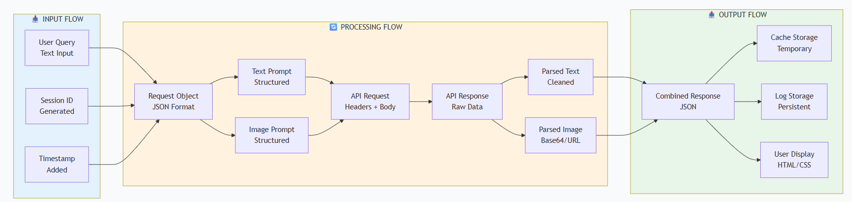

2.4. Components Design
The system consists of multiple components, each responsible for a specific function.
User Interface
This component provides a platform for user interaction. It allows users to enter queries and view results.
Backend Application
This component handles request processing, API communication, and response generation. It acts as the core of the system.
Docker Container
This component packages the application and its dependencies into a single unit. It ensures portability and consistency.
Kubernetes Deployment
This component manages the deployment of application containers. It ensures that the required number of instances are always running.

Kubernetes Service
This component exposes the application to external users. It provides load balancing and ensures that user requests are distributed across multiple instances.
CI/CD Pipeline
This component automates the process of building, testing, and deploying the application. It ensures faster and more reliable updates.
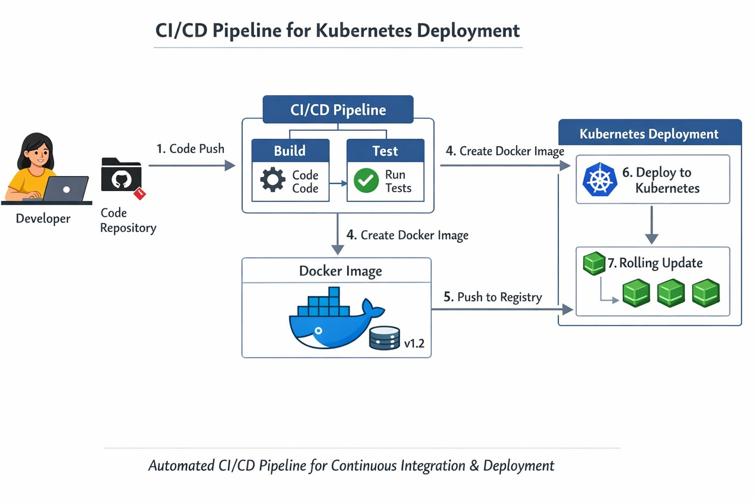
External AI Services
These components provide the functionality for generating text and images.
Logging and Monitoring Module
This component tracks system activities, errors, and performance metrics. It helps in debugging and maintaining system reliability.

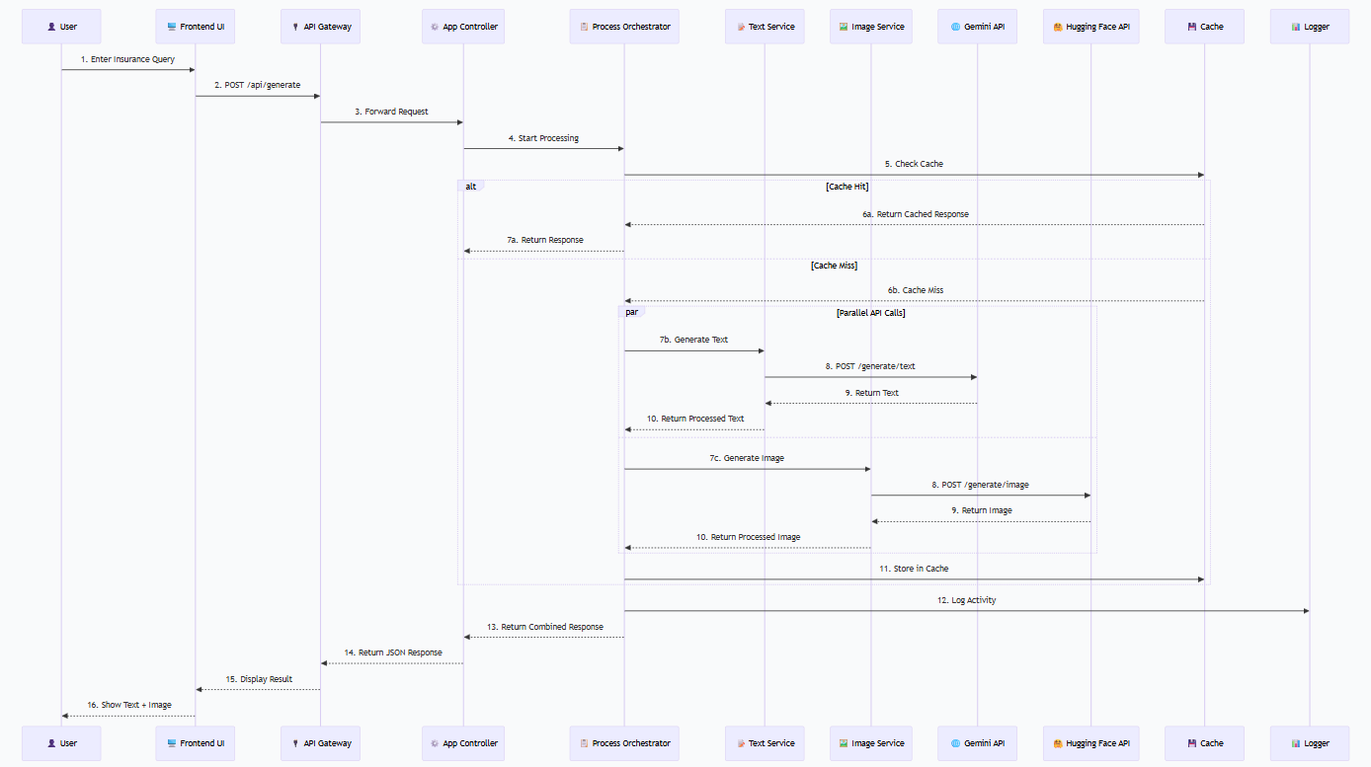
2.5. Key Design Considerations
The system design is based on several important considerations:
Modularity
Each component is designed to perform a specific task. This makes the system easier to manage and update.

Scalability
The system can handle increased load by adding more instances through Kubernetes.
Reliability
Kubernetes ensures that failed components are automatically replaced.
Zero Downtime Deployment
Rolling updates allow new versions of the application to be deployed without interrupting service.
Maintainability
The system is structured in a way that allows easy updates and improvements.

2.6. API Catalogue
The system uses both internal and external APIs.
User API
Handles user requests and sends them to the backend.
Backend API
Processes requests and manages system logic.
Text Generation API
Generates simplified explanations.
Image Generation API
Generates supporting visuals.
CI/CD API
Automates deployment processes.
Kubernetes API
Manages cluster resources and deployments.

3. Data Design
The data design section explains what type of data is used in the system, how it is handled during execution, and how it is managed within the DevOps deployment environment.
The Multimodal Insurance Creator primarily works with dynamic and request-based data, as it generates outputs in real time using AI services. Unlike traditional applications, it does not rely heavily on long-term data storage. However, certain types of data such as logs, request metadata, and temporary session data are maintained for operational purposes.
The data design is kept simple and efficient to ensure faster processing, reduced storage overhead, and easy scalability.
3.1. Data Model
The system uses a simple logical data model with the following main data objects.
1. User Query
This entity represents the input provided by the user.
Fields include:
- Query ID
- Query Text
- Timestamp
- Session ID
- Request Status
This data is used as the starting point for processing and is passed through different layers of the system.

2. Response Record
This entity stores the output generated by the system.
Fields include:
- Response ID
- Query ID

- Text Output
- Image Output
- Generated Timestamp
- Status
The response record is usually temporary and may not be stored permanently unless required for logging or analysis.

3. Deployment Metadata
This entity is specific to the DevOps environment and tracks deployment-related information.
Fields include:
- Build ID
- Docker Image Version
- Deployment Version
- Pod Status
- Deployment Timestamp
This data helps in tracking system versions and debugging deployment issues.

4. Log Record
This entity stores system logs and monitoring data.
Fields include:
- Log ID
- Event Type
- Event Message
- Timestamp
- Component Name
- Status

Logs are important for debugging, monitoring performance, and identifying system failures.
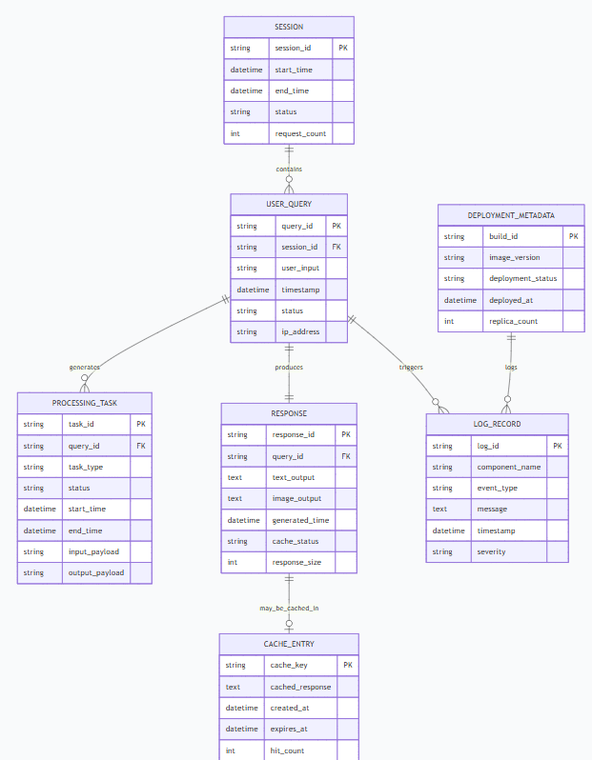

3.2. Data Access Mechanism
The system follows a controlled data access mechanism to ensure consistency and security.
Data is accessed through the following methods:
- API-based communication:
All data exchange between frontend, backend, and external services happens through APIs.
- Internal data flow:
Data is passed internally between components such as backend modules and deployment services.
- JSON format:
Data is transferred in structured JSON format for easy processing.
- Kubernetes environment variables and secrets:
Sensitive data such as API keys are accessed securely using Kubernetes secrets.
Direct access to internal data storage is avoided to maintain data integrity and prevent unauthorized access.
3.3. Data Retention Policies
The system follows a minimal data retention approach.
- User queries are stored temporarily during processing
- Generated responses are not permanently stored unless required
- Logs are stored for monitoring and debugging purposes
- Deployment data is stored for version tracking
Old or unused data is removed periodically to reduce storage usage and improve performance.
3.4. Data Migration
At the current stage, the system does not require data migration because it does not maintain a persistent database.
However, in future enhancements, if cloud storage or databases are introduced, data migration may be required when:
- Moving from local storage to cloud storage

- Updating data structures
- Scaling the application
Data migration should follow standard steps such as validation, transformation, and verification to ensure data consistency.

4. Interfaces
The system includes multiple types of interfaces that enable communication between different components.
User Interface
The user interface is responsible for interacting with the user. It allows users to input queries and view results. The interface is designed to be simple and user-friendly.
Application Interface
This interface connects the frontend with the backend. It receives user input and forwards it to the backend for processing. It also sends the final response back to the user interface.
Kubernetes Interface
This interface manages communication between the deployment system and the Kubernetes cluster. It is responsible for:
- Deploying containers
- Scaling applications
- Managing pods and services
CI/CD Interface
This interface connects the source code repository with the deployment pipeline. It handles:
- Code integration
- Build automation
- Deployment triggers
External API Interface
This interface connects the system with external AI services. It handles:
- Sending prompts
- Receiving responses
- Error handling

5. State and Session Management
The system follows a stateless architecture, which means that each request is processed independently without storing long-term session data.

- State Management
During processing, the system maintains temporary states such as:
- Request received
- Processing in progress
- Response generated
These states exist only during the execution of a request.

- Session Management
A session ID may be used to track a single user interaction. This helps in:
- Linking requests and responses
- Tracking user activity
- Debugging issues
Sessions are short-lived and are cleared after the request is completed.

- Kubernetes Role in State Management
Since Kubernetes manages multiple instances (pods), stateless design ensures that any pod can handle any request without dependency on previous states.
. 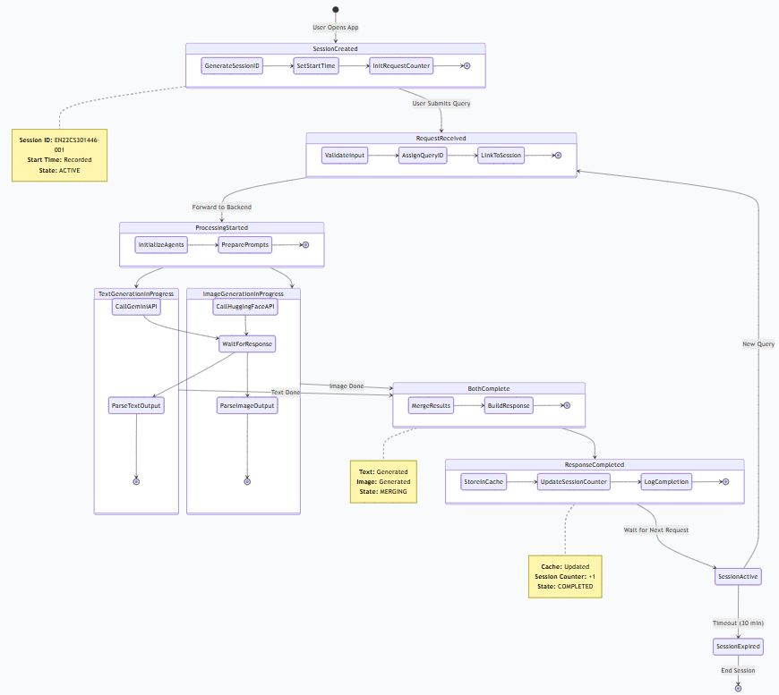

6. Caching
Caching is used to improve system performance and reduce unnecessary processing.
Caching Strategy
The system may cache:
- Frequently asked insurance queries
- Common AI-generated responses
- Static reference data
Benefits of Caching
- Reduces response time
- Decreases API usage
- Improves system efficiency
Cache Management
- Cache entries are temporary
- Old entries are removed periodically
- Cache is updated when new responses are generated

7. Non-Functional Requirements
Non-functional requirements define the expected behavior and quality of the system.
The system should be:
- Reliable
- Scalable
- Secure
- Efficient
- Maintainable
7.1. Security Aspects
Security is an important part of the system design, especially because the system interacts with external APIs and handles user input.
- Security Measures
- Input Validation:
Ensures that user input is safe and properly formatted
- Secure API Keys:
API keys are stored securely using environment variables or Kubernetes secrets
- HTTPS Communication:
All data transfer is encrypted
- Access Control:
Limits access to system components
- Error Handling:
Prevents exposure of internal system details
- Kubernetes Security
- Role-based access control (RBAC)
- Secure container images
- Network policies
.

7.2. Performance Aspects
Performance defines how efficiently the system handles user requests.
Performance Factors
- API response time
- Backend processing speed
- Network latency
- Kubernetes scaling efficiency

Performance Optimization
- Parallel API calls for text and image generation
- Efficient backend logic
- Use of caching
- Load balancing using Kubernetes services

Scalability through Kubernetes
Kubernetes improves performance by:
- Automatically scaling pods
- Distributing load
- Handling failures

Zero Downtime Deployment
Rolling updates ensure that:
- New versions are deployed gradually
- Old versions are replaced without stopping service
- Users do not experience downtime

8. References
The following resources were used for designing the system:
- Kubernetes Official Documentation
- Docker Documentation
- GitHub Actions / Jenkins Documentation
- Google Gemini API Documentation
- Hugging Face API Documentation
- Python Documentation
- DevOps Best Practices Guides

